Name:V.Siri Chandana
ROLL NO: 2520030609
Section:2
DBSE &DBD Week 9
Created a Folder with name: frontend
Installed vite in the the folder along with npm axios and react router dom
Then created a sub folder called client with required components
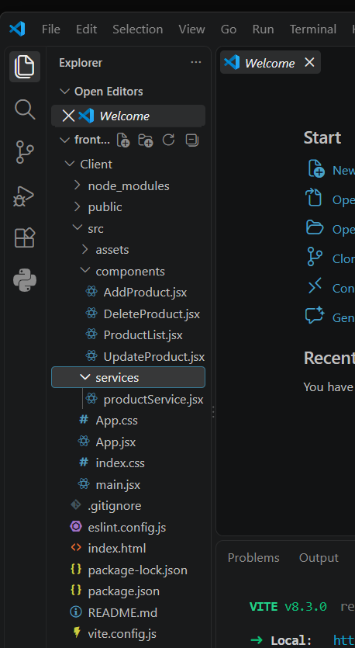
After adding respective codes into the files
Done the frontend part
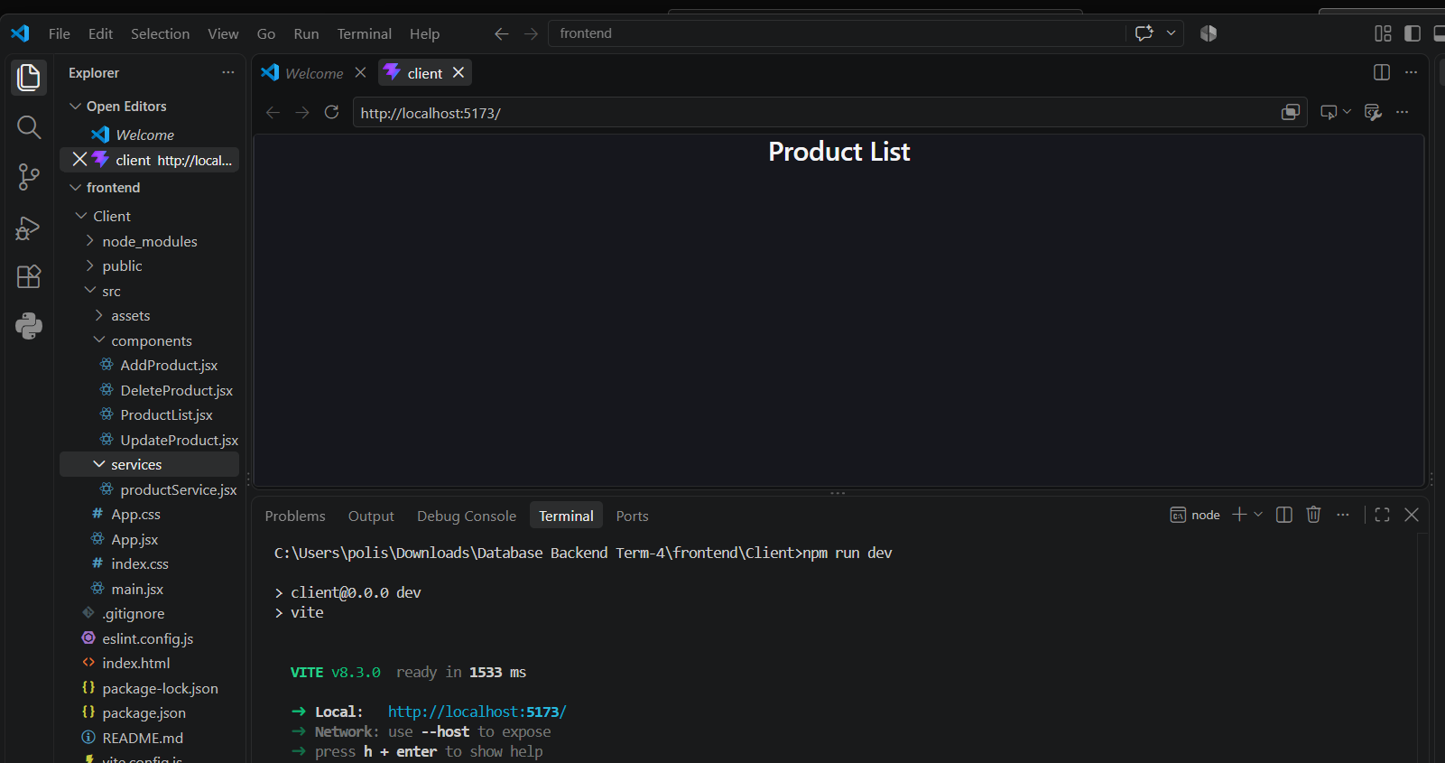
The below screenshot says that we can add products
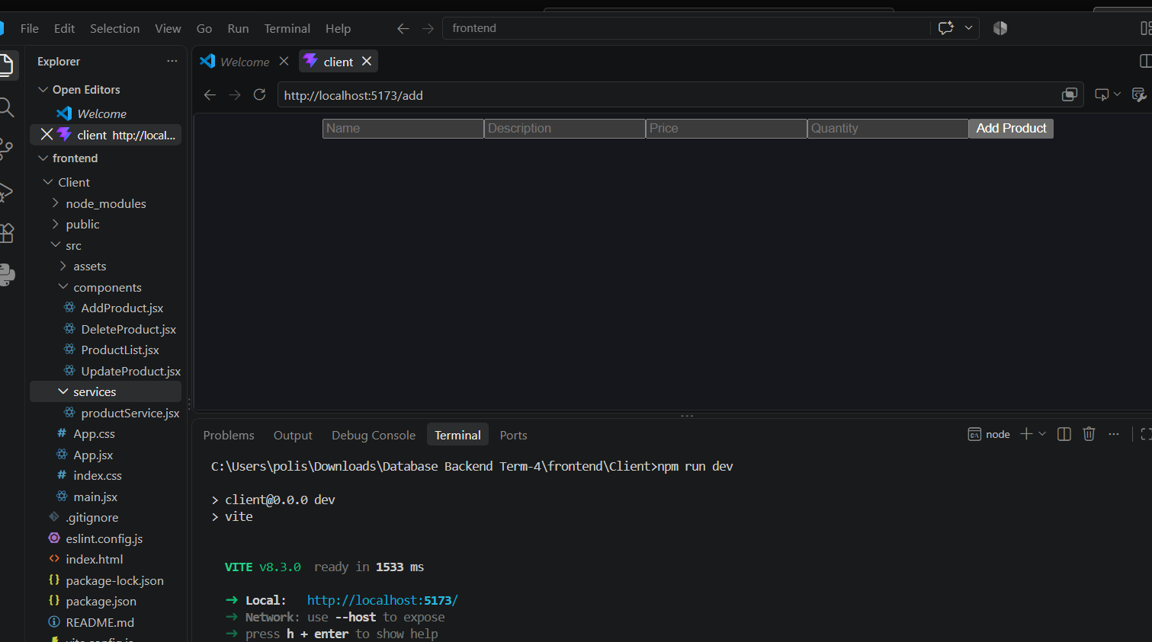
Then next Set up the backend by spring tool
1) Created a new Spring starter project called Product React
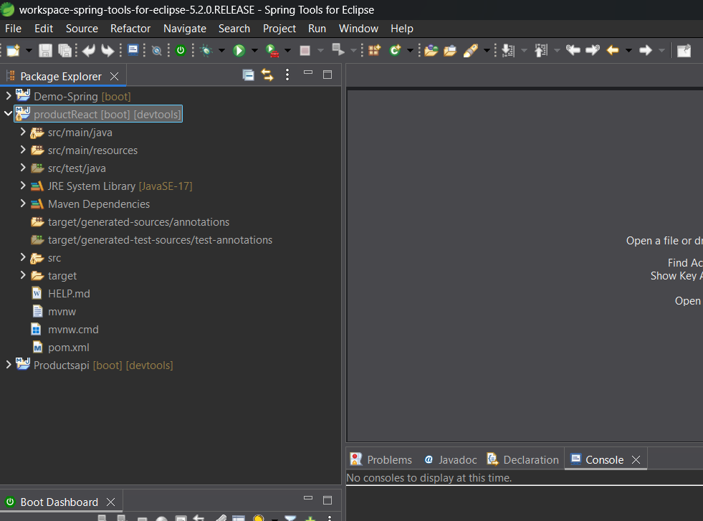
then create the packages as shown in below picture with their req. class
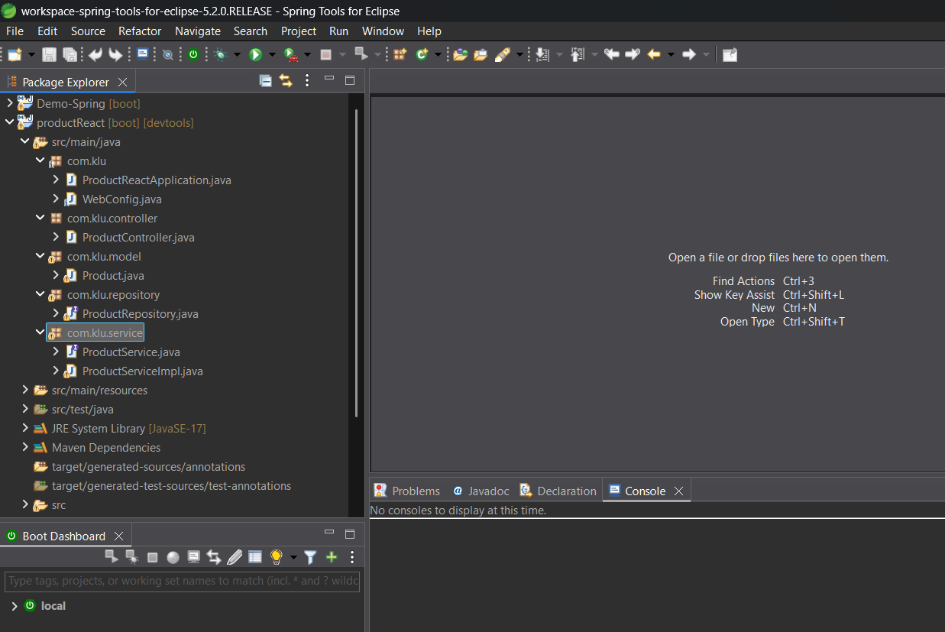
And added respective code in those files
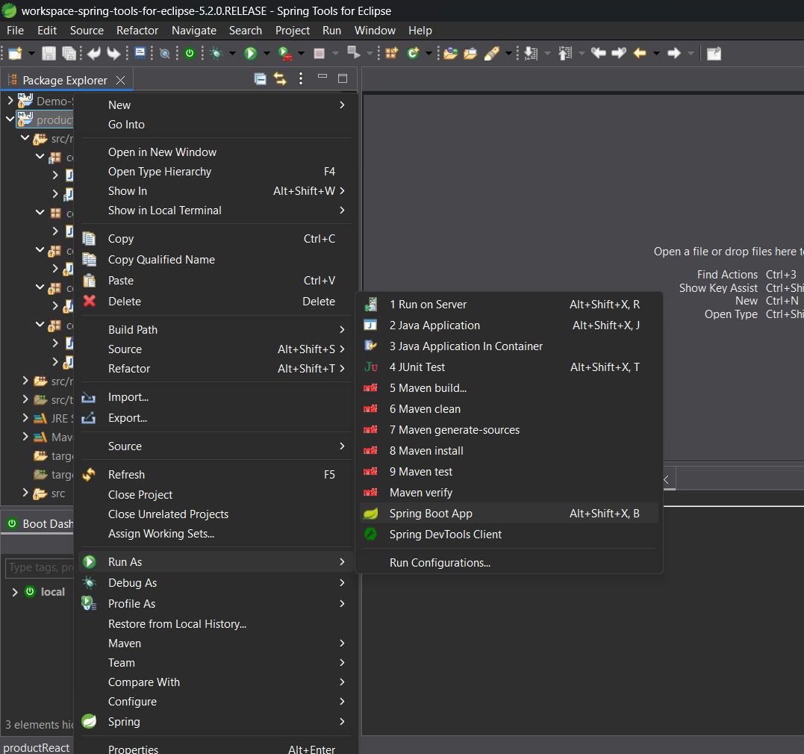
Run the application as spring boot app
With the help of this the spring tool is like a backend between our frontend folder and databse mysql so the frontend is live now and the data which we enter in live frontend application will be stored in databse
